2. What is the state of free speech for those with controversial views on college campuses?

3. How conservative is Trump’s agenda?

4. Is FBI Director James Comey still a trusted presence in Washington?

5. How are Trump’s recent tweets playing with his base?

6. Is Trump’s plan to increase military spending wise in the face of proposed cuts to
domestic programs?

7. Is Trump on the right side of the transgender issue?

8. How is Supreme Court nominee Neil Gorsuch progressing towards confirmation?

9. Will Trump’s revised travel policy prove more acceptable?

10. What does the recent drop in border crossings across the Mexican border indicate?

11. How can we assess Trump’s first 50 days in office?

12. How can the nation best respond to the opioid crisis?

- What has been the impact on the Indian community in America after the recent shooting of two Indian men?

1. What does Emmanuel Macron need to do to win the Presidency of France?

2. What must happen to bring stability to South Korean politics?

3. Will President Hassan Rouhani retain the Presidency of Iran?

4. Will Ellen Johnson Sirleaf be successful in leading Liberia?

5. What can the UN do to avert famine in Africa?

6. How can Mexico forge a working relationship with the Trump administration?

8. How should NATO respond to the deployment of the Russian Topol cruise missile?

9. Can Israel and Russia find any common ground on the conflict in Syria?

10. Would it be beneficial to send more American troops to Afghanistan?

11. Will Argentine unions be able to impact their government’s plan for public spending cuts?

12. What can be done to improve German-Turkish relations?

7. How viable is the recent Chinese proposal to suspend military activity on the Korean peninsula?

1. Why is the U.S. trade deficit at a near record high?

2. Should Congress implement Trump’s idea of lowering the corporate tax rate to 15%

3. Would Trump’s 1 trillion dollar infrastructure plan be a budget buster?

4. How would implementation of the Republicans’ health care plan affect the government as a whole?

5. Is it time for the FED to raise interest rates?

6. Should Dodd-Frank be repealed?

7. Would removing restrictions on coal production produce any significant economic benefit to coal country?

8. What would be the economic implications of Trump’s revised travel ?

9. Have Freddie Mac and Fannie Mae outlived their usefulness?

10. How will Brexit affect America’s economic bottom line?

11. How would the building of Trump’s wall affect the economy of the Southwest?

12. Is “RyanCare” going to be a gift to the rich?

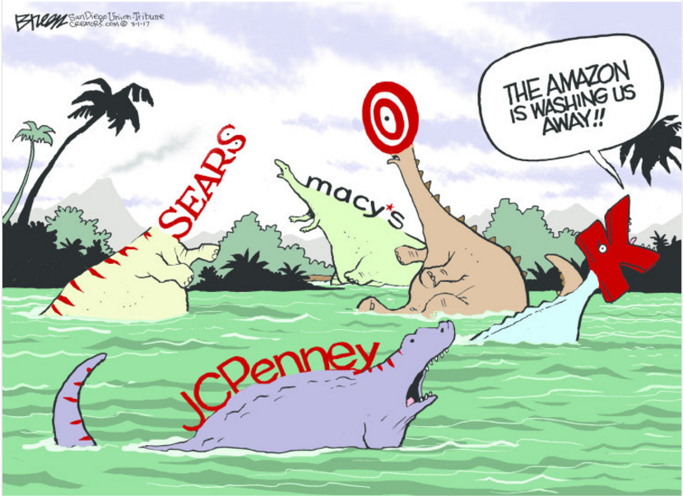
1. Are brick & mortar stores going the way of the dinosaurs?

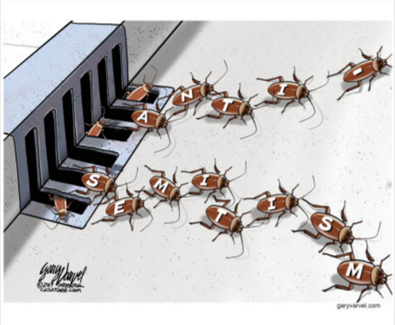
2. What can be done to curb the rise of anti-semitism in the U.S.?
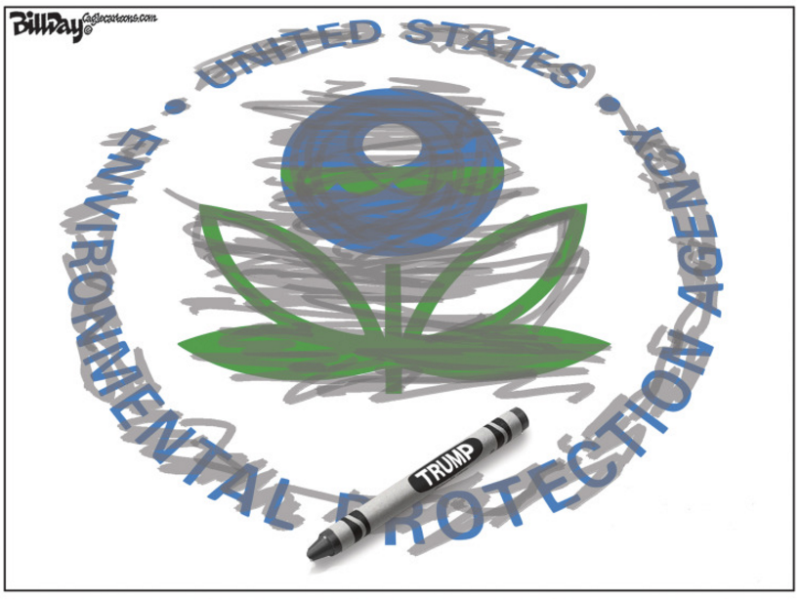
3. Is the EPA in danger of being erased under Scott Pruitt?

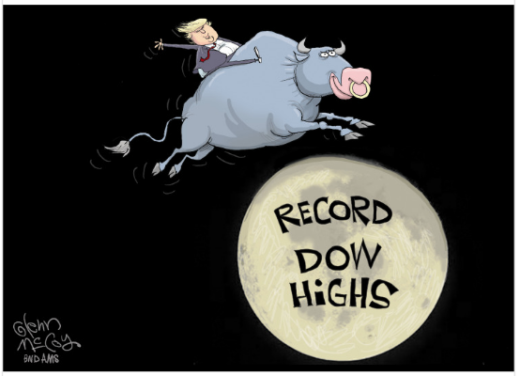
4. What’s the story behind record Dow Highs?

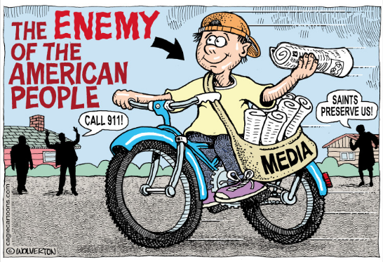
5. Is mainstream media the enemy?

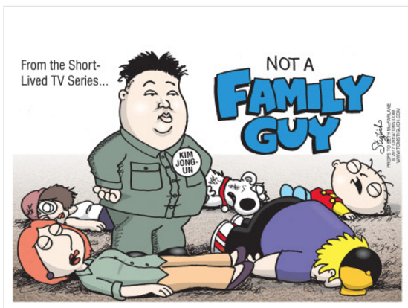
6. Is anyone in Kim Jong-Un’s family safe?

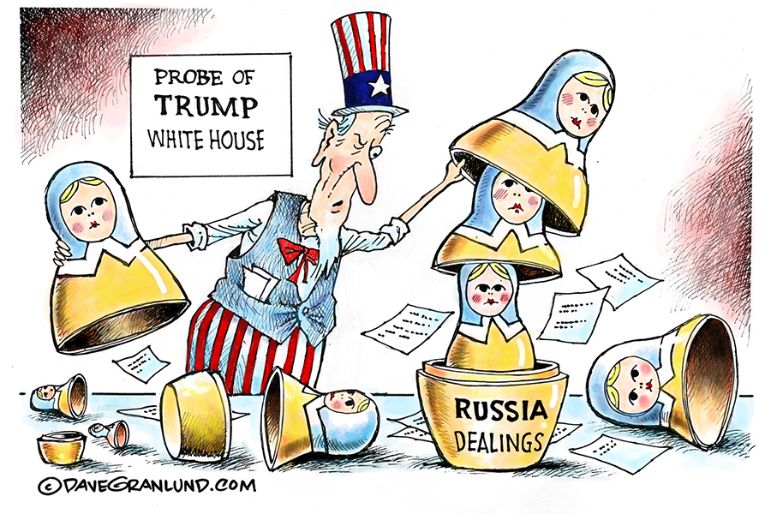
7. Will Russia ultimately be Trump’s undoing?

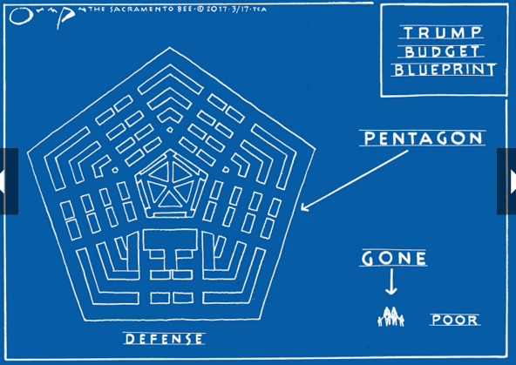
8. Is Trump’s budget proposal what’s right for America today?

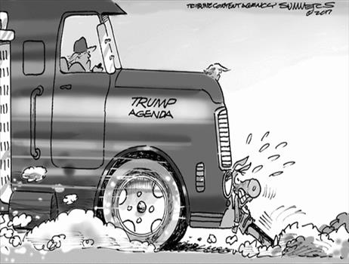
9. Can Democrats do anything to slow the Trump agenda?

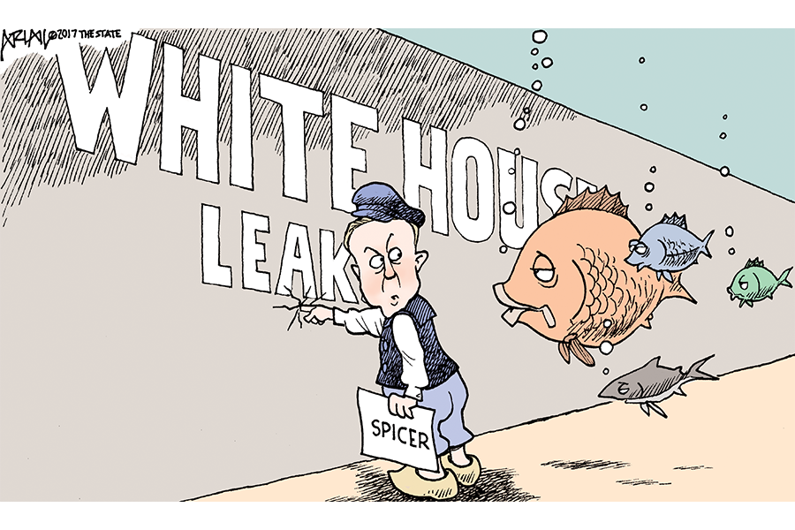
10. Should more be done to stem the leaks coming out of the White House?

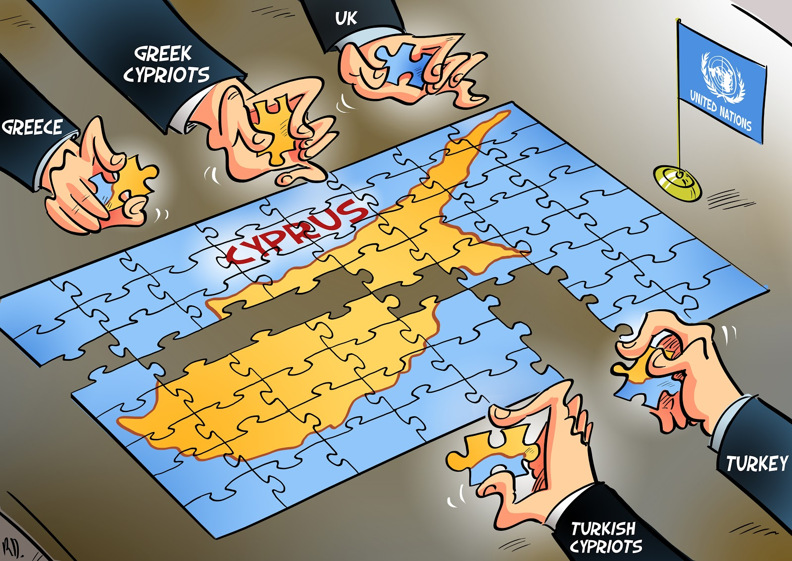
11. Can the UN piece together peace on the island of Cyprus?

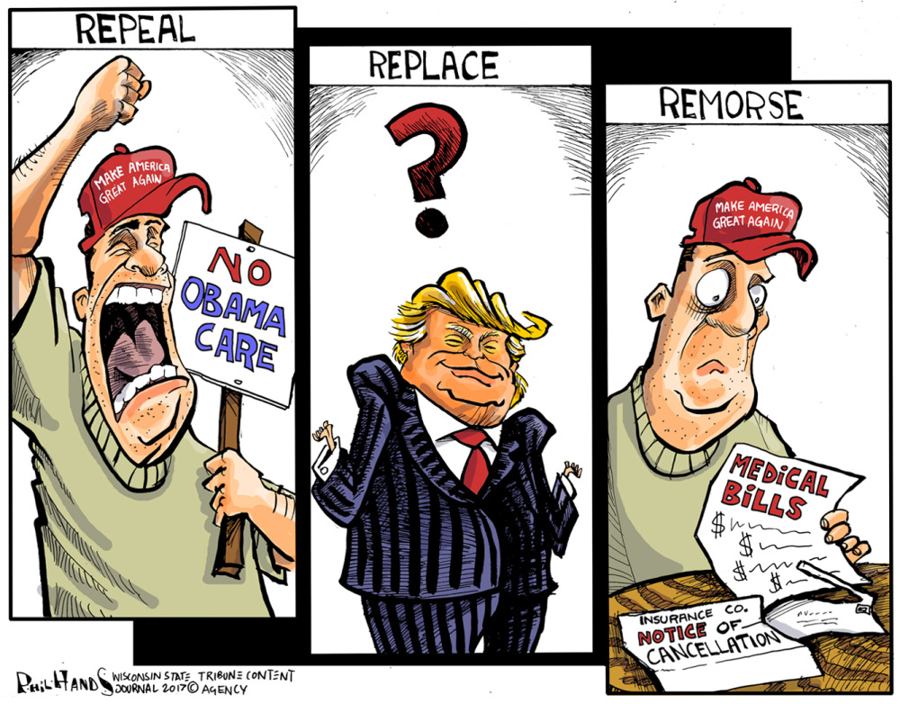
12. Will Americans feel remorse over Republican-style health care reform?

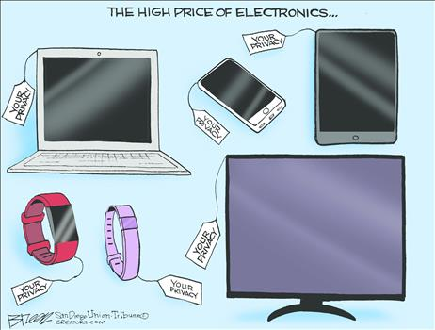

13. Is privacy the true cost of being “connected” through our smart devices?

